INCREASE
INCREASING THE PENETRATION OF RENEWABLE ENERGY SOURCES IN THE DISTRIBUTION GRID BY DEVELOPING CONTROL STRATEGIES AND USING ANCILLARY SERVICES
Questionnaire on the relevant experiences

Document info

Project Number | 608998 – INCREASE
Funding Scheme | Collaborative Project
Work Programme | Topic ENERGY.2013.7.1.1: Development and validation of methods and tools for network integration of distributed renewable resources
Number | Q1.1
Title | Questionnaire on the relevant experiences
Dissemination Level | PU
Date | 18.12.2013
Nature | Questionnaire
Author | Andrej Gubina, UL
Contributor | Andreas Tuerk, JR
Reviewers | Bart Meersman, Sophie Gillaerts, UGENT

Document History
Date | Author | Action | Status
16.12. | Andrej Gubina | Draft version of the questionnaire | Submitted for review
16.12 | Sophie Gillaerts | Second version of the questionnaire
17.12 | Bart Meersman | Final version of the questionnaire | Final version

Information about the interviewed organisation

Datum: |  | Organisation:
Name: |  | Position:
E-mail: |  | Tel.:
Comments:

Objective

The INCREASE project will focus on how to manage renewable energy sources in LV and MV networks, to provide ancillary services (towards DSO, but also TSOs), in particular voltage control and the provision of reserve. Control strategies for grid-connected inverters will therefore be developed. Furthermore, INCREASE will investigate the regulatory framework, grid code structure and ancillary market mechanisms, and propose adjustments to facilitate successful provisioning of ancillary services that are necessary for the operation of the electricity grid, including flexible market products.

This questionnaire is part of the follow-up process to the INCREASE Kick-off conference and aims at gathering input from the different stakeholders. The questions are structured in groups. We would like to ask you to kindly fill out the questionnaire and provide us with the answers to the questions with as much detail as possible. The obtained information will help us better shape the work in the project!

Technology challenges

Planning
- When you receive a question for connecting a renewable energy unit to your (low voltage) network, do you make the necessary calculations to ensure a problem-free operation of your network?

1a. Alternatively, do you allow this unit to connect and only act when problems occur?
1b. Do you believe your way of handling is the optimal way, or do you feel that this is not a sustainable solution?

- What is the maximal power of a renewable unit to connect it via a single phase connection?
2a. Are there other solutions for preventing voltage-unbalance problems?
2b. Do you believe that an increased penetration of renewable energy units will always lead to voltage unbalance?

- Do you consider the single-phase inverters in the planning process? How you take this into account?
- In the network planning do you do only worst-case scenario analysis or also consider the load when planning the connection of renewables in the grid?
- Above which installed capacity a central circuit breaker is needed for a power plant?
- What kind of reactive power control mechanisms integrated in the power plant can the DSO prescribe?
- Please provide some links to the grid planning rules/laws etc. in your country (if possible in English).

Operation

- Are there any requirements on frequency dependable reduction of real-power?
1a. Do you think it is an actual problem or do you feel it will be important in the future?

- Are there any requirements for real-power reduction dependent on measurement voltage?
2a. Do you think it is an actual problem or do you feel it will be important in the future?
- Are there any requirements for the protection equipment?
3a. Are the protection systems changed in case of an increased penetration of renewable energy units?
- What is the maximal power (PV vs. Hydro) for certain transformer/line thermal capacity (e.g. what is the maximal capacity for a 100 kVA transformer)?
- What is the maximal power (PV vs. Hydro) for certain transformer/line thermal capacity (e.g. what is the maximal capacity for a 100 kVA transformer)?
5a. What is the accepted practice in your country in this regard?
- What is the stipulated power factor range for distributed generators?
6a. Are there any control curves that can be stipulated by the DSO?

Measurement

- Can the DSO prescribe an interface for real power reduction and access to the other measurements?
- Which measurements are currently available in the LV and MV network?
2a. Do you believe that in the near future more measurements will be installed?
- Are in your opinion measurements missing because you feel you lack insight in identifying problems in your network on time?

Proposed solutions

Control strategies

- Is the measurement on the low voltage transformer side useable for MV regulation?

Topology

The project INCREASE proposes communication and interaction topology among the agents of the MV and LV level.

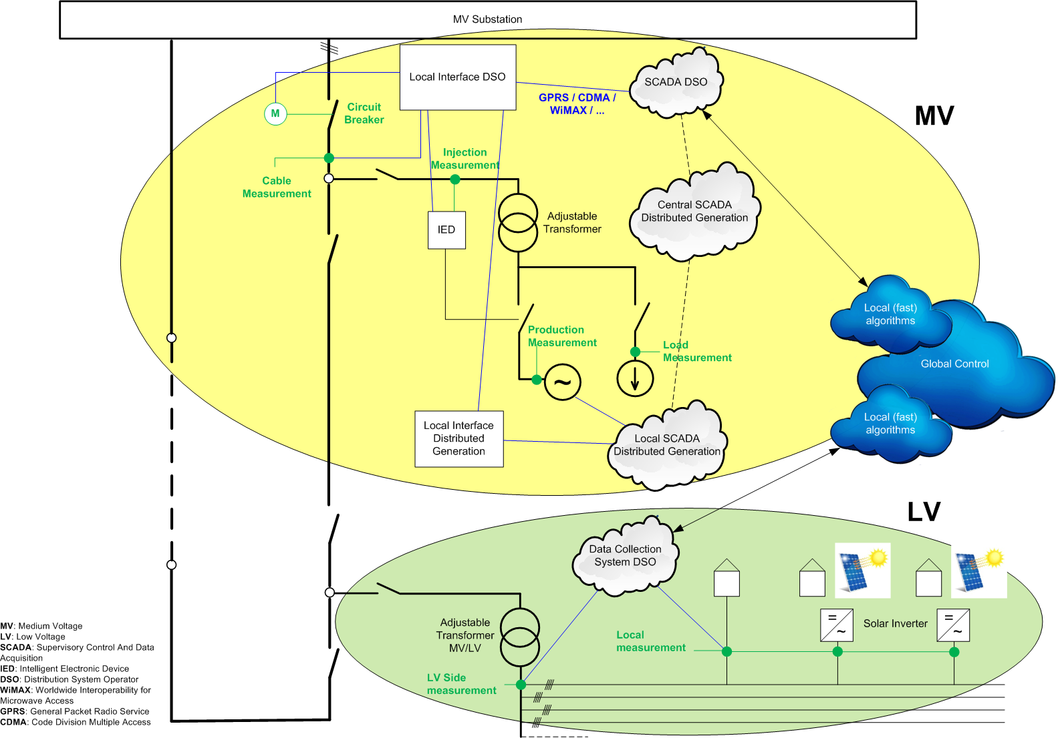

- What is the added value of this architecture?
- Which grid components in the topology are useful, and which are not?
- Can the proposed solutions be simulated, or are there fundamental theoretical or technical problems?
- Is it possible to carry out and demonstrate the proposed topology with the current technologies?
- Are some of the solutions technically infeasible? If so, why?

Financial support

The control system using intelligent control strategies proposed by the INCREASE project together with the ICT system architecture and inverter technology aim to investigate the ancillary services (voltage control and provision of reserve) which are provided by the distributed variable generation and consumer response. We wish to investigate the possibilities for market-based remuneration of the provision of these ancillary services.

- Prescription of AS within the Grid Codes may lead to minimum fulfilment of the Grid Code requirements. On the other hand, technology-independent market-based provision and remuneration of AS products would stimulate the providers to provide them in the most efficient manner possible. Do you agree?
- How to determine the benefits of AS provision in a MV or LV network?
2a. What metrics for the benefits could be of use?
2b. How to determine the contribution of each AS to this value?
- In the benefits determination, who are the stakeholders that we need to account for (DSO, TSO, consumers, generators…)?
- Since the TSO is the ultimate responsible for the secure operation of the network, do we need to account also the HV network effects?
- How to determine the costs of the AS provision?
5a. Is the framework of capability (investment costs) / readiness / dispatch (operating costs) adequate?
- In your country, who pays for the investment for the connection of a power plant into the grid at every voltage level (HV, MV, LV)?
- Do the investors have to pay for the grid access allowance (like 60 EUR)?
- Do the investors in the Renewable generation have to pay the grid connection fee?
- Which contracts are prepared with the investors (grid connection allowance, grid access contract, etc.)?

Regulatory Framework

The regulatory framework defines the legal boundaries for the proposed ancillary service products, as well as the proposed technical solutions and control strategies. The AS are usually described in the TSO Grid Code.

- Since we are investigating also the DSO level, we would need to look also in the DSO Grid Code. Do you know of an example (e.g. in your country) that some of the AS would be specified in the DSO Grid Code?
- What specific aspects of market provision of the AS (for voltage and reserve provision) should we take into account?
- How do you define penetration level of a selected technology in the system? What voltage level (LV, MV, HV, all) would be the right reference framework for its calculation?

Thank you for your help by providing us with the information!

